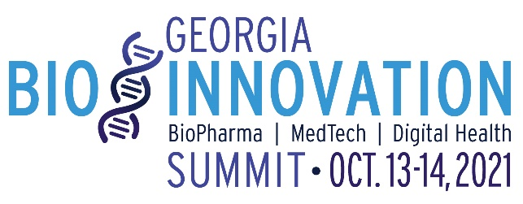
Georgia Bio Innovation Summit Boilerplate and Sample Descriptions

191 Words:
For more than 19 years, Georgia Bio has presented the Innovation Summit, welcoming 500+ CEOs, senior executives, scientists and public policy officials from Georgia and across the nation. We invite you to join us for this year’s virtual Innovation Summit October. 13-14 & 21, 2021.
The Summit provides a forum for professionals from industry, academia and government to discuss major trends and issues, including topics related to scientific research, product development, financing, business development and public policy. The Summit also provides a virtual exhibit hall, featuring the latest research, technology and services at companies, universities and other organizations.

This year’s Summit will highlight:
- Keynote presentations covering policy, global health, workforce development, and more!
- Breakout sessions featuring research & innovation in Georgia; business issues around diversity and industry academic collaboration; current and future state of the industry in the face of COVID-19; and industry best practices for life science industry professionals.
- A virtual exhibit hall, including purchasing programs that help you save.
- Showcase of innovations from Georgia organizations and individuals at the Scientific Poster Session, Company Showcase, Innovation Stage and PitchRound.
- One on One Partnering

Register: https://www.georgiabiosummit.org/register

Twitter:
- Register today for the @Georgia_Bio Innovation Summit on Oct. 13-14 & 21, 2021! The Summit will be held virtually and will showcase Georgia’s leadership in innovation. #GaBioSummit https://www.georgiabiosummit.org/
Facebook/LinkedIn:
- The @Georgia Bio Innovation Summit will be Oct. 13-14 & 21, 2021! Join us as we showcase Georgia’s leadership in innovation, from basic research to manufacturing, to improve the health and well-being of people, animals and the environment. #GaBioSummit https://www.georgiabiosummit.org/
- Register for @Georgia Bio’s Innovation Summit on Oct. 13-14 & 21, 2021! The Summit is Georgia's premier bioscience and medtech conference welcoming 500+ CEOs, senior executives, scientists and public policy officials from Georgia and across the nation. This is a 3-day program you don’t want to miss! #GaBioSummit https://www.georgiabiosummit.org/

